Legacy of Distinguished Citizens

2021: The Cristina Family
2020: Scouters on Front Line of Covid
2019: Jim & Gretchen Mair & Family
2018: Case Swenson
2017: Lon & Peggy Normandin & Family
2016: Shaun Del Grande
2015: Art Williams
2014: Maryles Casto & Marc Casto
2013: Jon Ball
2012: Vic Giacalone
2011: Mike Blach
2010: Marilyn & Frank Dorsa
2009: Bert George
2008: Dan & Sheila* Breeding
2007: Helen and Eddie* Owen
2006: John & Christine Davis
2005: Barry Swenson
2004: Charles Toeniskoetter
2003: Robert S. Kieve*
2002: Steve Caplan
2001: William J. Del Biaggio, Jr.*
& Family
2000: John Sobrato & Family
1999: Jim Evers
1998: Armon Mills

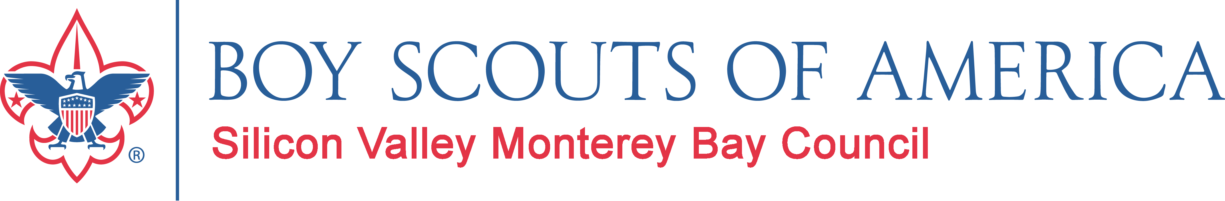

1997: Michael & Mary Ellen Fox
1996: Ben Reichmuth*
1995: S. Reid Gustafson
1994: Murphy Sabatino*
1993: Carl E. Cookson, Sr.*
1992: William Smythe*
1991: Susanne Wilson*
1990: Albert J. Ruffo*
1989: Ray A. Silva*
1988: Kimball W. Small*
1987: Donald L. Lucas*
1986: Robert M. Hosfeldt*
1985: Jan W. Passmore
1984: Thomas T. Vais*
1983: Robert A. Fuhrman*
1982: Enide Alison*
1981: Halsey C. Burke*
1980: Rev. Philip Barrett*
1980: Rabbi Joseph Gitin*
1980: Fr. Walter Schmidt*
1979: Stanley Chinchen
1978: Glenn A. George*
1977: William Hewlett*
1976: P Anthony Ridder
1975: Dr. Frank Bernard*

* Deceased

