**Pioneer District Nominations are Due by November 2nd to Steve Ricossa sricossa@gmail.com.**

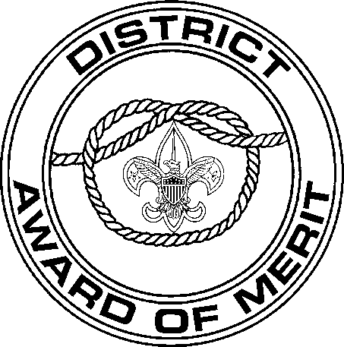
NOMINATION
FOR THE

DISTRICT AWARD OF MERIT

District Award of Merit

NOTE: The nomination is confidential. To avoid possible disappointment, please do not advise nominee in any
way of your action in his or her behalf.
Council District Unit

TO THE DISTRICT AWARD OF MERIT COMMITTEE:
It is a pleasure to present for your consideration for the DISTRICT AWARD OF MERIT:

Name Address
City or Town Zip

Currently registered in Scouting as The nominee has earned the following (provide dates):
Den Leader’s Training Award Scouter’s Religious
or Den Leader Award Award Other (specify)

Den Leader Coach’s Training Award Silver Beaver or Den Leader Coach Award

Cubmaster Award

Cub Scouter Award

Webelos Den Leader Award

Scouter’s Training Award
Order of the Arrow

Wood Badge

Venturing Awards

Distinguished Commis-
sioner Service Award

Scouter’s Key

The noteworthy service upon which this nomination is based follows:
(Furnish as much information as possible. For example: president, Rotary Club; vestryman, St. Paul’s Church; chairman, Red Cross campaign; vice-president, PTA; medical director, hospital; Cubmaster, 3 years; Scoutmaster, 4 years; Venturing Advisor, 3 years; commissioner, etc. Use additional paper, if necessary.)

Date of nomination
Name of person making nomination
Position in Scouting
Contact number

GENERAL INFORMATION
The District Award of Merit is a council award presented by districts in the same manner that the Silver Beaver is a national award presented by councils.
The award is available to Scouters who render service of an outstanding nature at the district level.
The award is made available annually on the basis of 1 for each 25 traditional units or fraction thereof. The district need not present all the awards to which it is entitled each year.
It is not appropriate to nominate a Scouter who has already received this award.
A professional Scouter or other council employee may not receive this award based on employment service. However, a profes- sional Scouter or employee who also serves as a volunteer Scouter may be eligible, based on volunteer service.

REQUIREMENTS
- A nominee must be a registered Scouter.
- A nominee must have rendered noteworthy service to youth in Scouting, outside Scouting, or both.
Note: The nature and value of “noteworthy service to youth” may consist of a single plan or decisions that contributed vitally to the lives of large numbers of youth or it may have been given to a small group over an extended period of time.
- Consideration must be given to the nominee’s Scouting position and the corresponding opportunity to render outstanding service beyond the expectations of that Scouting position.
- The nominee’s attitude toward and cooperation with the district and/or council is to be taken into consideration.
- Nominations cannot be considered for posthumous awards.

PROCEDURE
- Annually, district chairmen will appoint a temporary special District Award of Merit committee of not more than five persons who will consider all candidates and make recommendations of those to receive the award to the council through the Scout executive.
- The Scout executive will inform the district chairman of those nominations approved by the council committee.
- The following procedure is suggested for such presentation ceremonies:
  - The recipient and spouse should be in attendance at the annual meeting or recognition dinner.
  - A district and/or council officer should explain the award and its significance.
  - Eagle Scouts or Silver Award Venturers should be asked to escort the recipients to a place of honor at the head table or on stage.
  - A suitable citation for each recipient should be read indicating what each has done in Scouting.
  - The award (certificate, No. 33719; plaque, No. 17565; and lapel pin, No. 17551) may be presented at this time with appro- priate congratulations.
  - The only uniform insignia which accompanies this award is an embroidered overhand knot, No. 05013.
  - A group picture may be taken for use in neighborhood or community newspapers (district responsibility).

District approval Council approval

#33720C

30176

7 33720 3
Boy ScoutS of AmericA
1325 West Walnut Hill Lane
P.O. Box 152079 Irving, Texas 75015-2079 http://www.scouting.org

33720C 2014 Printing

