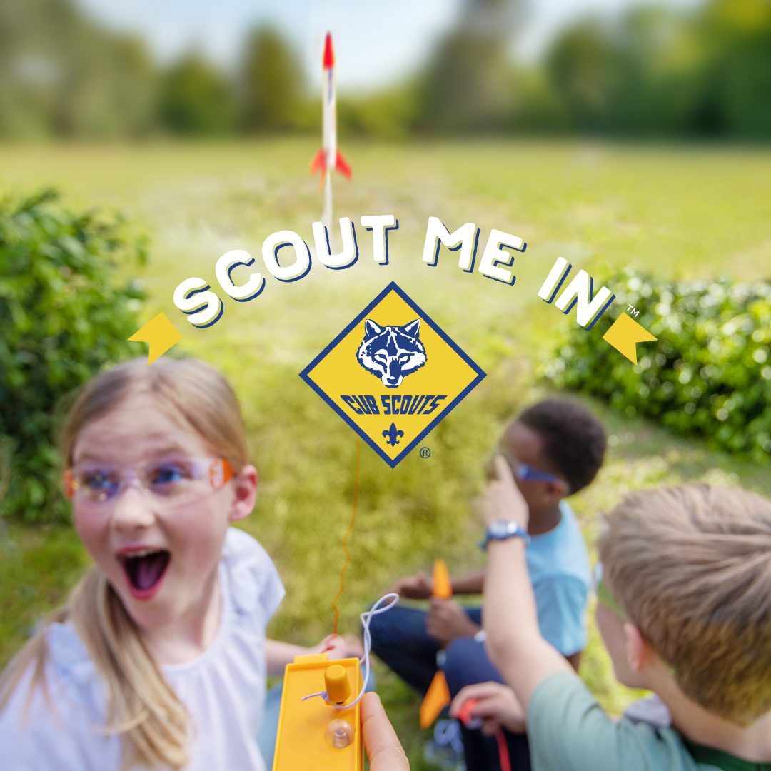
Hey Neighbors!
Interested in family friendly outdoor fun with your children? Looking for a fun adventurous program that also teaches valuable life skills? Check out Cub Scouts! Our family loves the program and think yours will to!
Cub Scouts teaches valuable life skills, self-confidence, and how to be a good family member and friend, all through fun, engaging outdoor adventures! Now available for Boys and Girls in Kindergarten – 5th Grade, Cub Scouts is a great way to make the best of family time together with your children. To learn more or connect with the Cub Scout program in our area, please visit www.beascout.org or contact us at (408) 638-8300 or membership@svmbc.org.
(LOCAL UNITS SHOULD SUBSTITUTE LOCAL CONTACT INFO)

